# Module 2 Activity 1: Basic Static Web Project Using Node.JS and EJS

# Brandon Trinkle

# IFT 458: Middleware Prog & Database Sec

# Professor: Dinesh Sthapit

# Jan 17, 2025

# Module 2 Activity 1: Basic Static Web Project Using Node.JS and EJS

1. *Terminal window demonstrating the installation of EJS using the command*

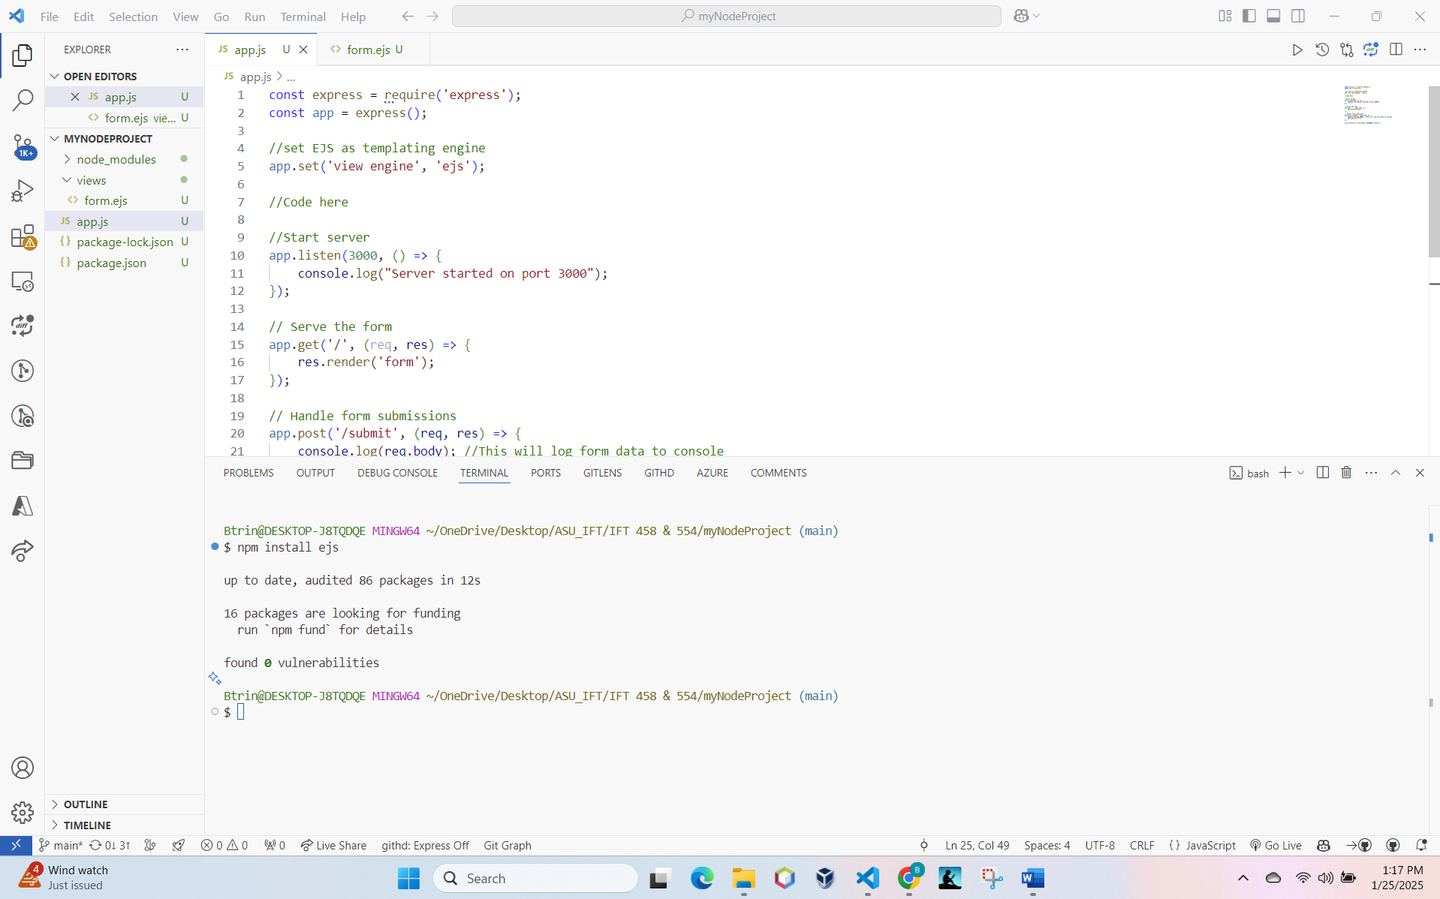

1. *Visual Studio Code explorer displaying the creation of a new file named "app.js" within the project folder.*

1. *Editor view in Visual Studio Code showing the opened "app.js" file with code for setting up Express.js server and importing Express module.*

1. *Visual Studio Code explorer displaying the creation of a new folder named "views" within the project folder.*

1. *Visual Studio Code explorer displaying the creation of a new EJS file named "form.ejs" inside the "views" folder, showcasing HTML code for the form.*

1. *Visual Studio Code explorer or editor showcasing the added code in "app.js" to handle form submissions and parse incoming request bodies.*

1. *Terminal window executing the command node app.js to run the Node.js application and display the server running on* [*http://localhost:3000*](http://localhost:3000)

